BUDGET DEBATE 2022
ROUND-UP SPEECH
Contents
A. Introduction 2
B. Securing our Future 4
Supporting SMEs 9
Focusing on Capabilities 11
Help for Other Segments 17
C. Raising Revenue – GST and other options 19
Managing Expenditure Increase 19
Spending More from the Reserves 25
Other Revenue Options 35
Corporate Income Tax 36
Personal Income Tax 38
Wealth Taxes 40
Externality Taxes 43
Addressing Concerns about GST 44
Exempting Essentials from GST 49
Overall Tax System 55
D. A Fair and Progressive Budget 59
E. Conclusion 72

Introduction
- Mr Speaker, I thank all Members who have spoken and supported the Budget.

- Many suggestions have been raised.

    - I cannot cover all of them in this round-up speech.

    - But I assure everyone that we have listened to every view, and will study your suggestions carefully.

    - Members have also raised many specific questions related to the programmes of the Ministries, and these will be addressed at the Committee of Supply.

- Sir, this Budget sets out the roadmap for Singapore to adapt and thrive in a post-pandemic world. We are charting our way forward together – towards a fairer, greener and more inclusive society. From what I have heard during the debate, there is strong support for these key thrusts of the Budget, and I thank everyone for the support.

- The key issues raised during the debate can be summarised in three broad questions.

    - Are we doing enough to sustain our recovery and position Singapore well for the future?

    - Why do we need more revenues, and in particular, why raise GST and are there alternatives to this? And

    - Is the Budget fair to all Singaporeans?

- I will address these three issues in turn.

Securing our Future
- Let me start with the overall economic situation. Ensuring a strong and vibrant economy is of critical importance – because it raises our standard of living; provides good jobs and opportunities for Singaporeans; and generates revenues, so that we have the resources to do more, especially for the more vulnerable groups.

- In my Budget speech, I shared our outlook for the year and some of the risks on the horizon, including the tensions in Eastern Europe. Since then, as we all know, the situation has escalated sharply, following Russia’s invasion of Ukraine.

- The Minister for Trade and Industry has provided an update of the economic outlook.

- Singapore’s direct trade linkages with Russia and Ukraine are relatively small.

- But the conflict will impact the global economy and global energy markets, which will in turn affect us.

- We are taking actions to enhance the resilience of our energy supplies. We are coordinating actions across the whole of society, as some members have suggested. For example, extending the Temporary Electricity Contracting Support Scheme (TRECS) to help affected consumers, especially the SMEs. We are getting businesses to offer more value-for-money house brands to consumers so that they can stretch their dollar. We are extending Price Kaki to help consumers make better, more informed purchasing decisions. And we are standing up the Committee Against Profiteering to take action against unfair price hikes.

- Where inflation risks are concerned, MAS had taken the pre-emptive step to tighten monetary policy in January. The appreciating exchange rate will moderate the impact of higher global inflation. MAS will continue to assess the appropriate steps to ensure medium-term stability.

- In this Budget, we introduced the Jobs and Business Support Package to help businesses and workers, as well as the Household Support Package to help households with their daily needs.

- Let me be clear, this Budget is expansionary, and our fiscal stance is appropriate. We are staggering the tax moves, with the first step of the GST increase taking effect only next year, and with generous offsets for all Singaporean households.

- We are monitoring the external situation, and the risks for our economy closely – risks in terms of both growth and inflation. If the situation worsens, we will not hesitate to take further actions to protect jobs, and to help households and businesses deal with increased costs.

- Notwithstanding these near-term uncertainties in the external environment, our overall prospects are good.

- We are operating from a position of strength.

- This is why we can make bold moves now, which will position us well to seize the opportunities ahead.

- One decisive step is to accelerate the decarbonisation of our economy and achieve net zero by or around mid-century.

- All of us will have to adjust to the new levels of Carbon Tax to facilitate this green transition. But moving decisively will bring many benefits and open up new opportunities.

- For example, after the Budget, Members may have read that EDP Renewables, a global leader in the renewable energy space, announced plans to invest up to $10 billion, through a local firm Sunseap, to establish a clean energy hub in Singapore for the Asia Pacific region.

- As we attract more of such green investments, we will also step up training efforts to equip Singaporeans with the right skills to take on these new green jobs. As several members including Ms Poh Li San, Dr Koh Lian Pin and Ms Hany Soh highlighted, it will take a whole-of-society effort to achieve our climate ambition and we will certainly move forward in that direction.

- At the same time, we will continue our R&D efforts in emerging technologies like carbon capture and low-carbon hydrogen, as suggested by Dr Tan Wu Meng.

- All of these moves will enhance Singapore’s position as a choice destination for new investments in the green economy, and ultimately create many more good jobs for Singaporeans.

- Several Members, Mr Seah Kian Peng, Ms Denise Phua, worry that we are making too many changes at the same time – foreign worker adjustments, Progressive Wages, CPF, Carbon Tax etc. And that all these will add to cost pressures for businesses, at a time when demand is still weak for certain segments of the economy.

- I understand these concerns. That is why we are continuing to provide significant support to the harder-hit sectors, including through the Small Business Recovery Grant.

- We are also phasing in the new requirements.

- For example, the carbon tax increase will be staggered over three phases, from 2024 to 2030; the changes to the S-pass minimum qualifying salary will be implemented over three steps, from this year to 2025.

- But what we are doing is to be upfront, clear and transparent to businesses. We are announcing these moves well ahead of time, so that businesses can plan ahead and make the necessary adjustments.

Supporting SMEs
- Even as we make these policy moves over the coming years, we continue to pay very close attention to our SMEs, something which many Members spoke about.

- We will continue to help our SMEs upgrade and maintain a vibrant SME sector in Singapore. This includes our heartland enterprises, as mentioned by Mr Melvin Yong. In fact, our support and grant schemes for companies are designed to benefit SMEs the most.

- Prior to COVID-19, smaller firms were receiving about 12 times more grants from the Government, on a grant per dollar of revenue basis, compared to larger firms.

- Throughout the past two years, SMEs continued to receive significant help through schemes such as the Jobs Support Scheme, rental relief and financing schemes.

- In this Budget, 80% of the payouts from the new and enhanced schemes will flow to SMEs.

- Not every SME will get the same support. That is because our strategy favours SMEs which are actively training their workers and increasing their productivity.

- If the SME is prepared to make the effort, it will enjoy very generous co-funding.

- Under the Productivity Solutions Grant or the PSG, firms that undertake productivity solutions this year will receive significant support – for a $10,000 productivity project, the Government will pay up to $7,000.

- With the SkillsFuture Enterprise Credit, eligible firms can get additional funding for up to 90% of out-of-pocket expenses for their supported programmes.

- You can stack both schemes together. If you do so, SMEs only need to pay as little as $300 for a $10,000 productivity project.

- Mr Derrick Goh, Mr Edward Chia and several other Members who have spoken up passionately about SMEs will be heartened to know that we will intensify our outreach efforts to the SMEs – to let them know about the support schemes, and how to take advantage of them. We will proactively reach out to the SMEs, through our Trade Associations and Chambers, and Enterprise Singapore. At the same time, we are making it easier for SMEs to access information on schemes and available support, through the GoBusiness portal and SME Centres.

Focusing on Capabilities
- I recognise that the operating environment in Singapore can be challenging for businesses. We are no longer competing based on being a low-cost business location.

- Where we can, the Government will manage the pace of cost increases and make it easier to do business. For example, through GoBusiness Licensing, we have streamlined the number of regulatory touchpoints for food business owners from 14 to 1. This reduces the number of license applications that firms have to fill up and saves up to 14 days of turnaround time.

- Ms Janet Ang and Mr Edward Chia shared concerns from the business community on the availability of manpower. That is a key concern for many businesses and I fully understand. The current shortage of Work Permit Holders is partly due to the border restrictions. As we progressively open our borders, we are giving priority to bringing back workers that businesses urgently need, especially workers for the Construction, Marine and Process sectors. We should be able to clear the shortages within the next few months. At the same time, firms should continue to take full advantage of the various schemes that support job redesign and improve productivity, to become more manpower-efficient.

- In the near term, the Government will also help to offset some of the cost increases. For example, we have the Progressive Wage Credit Scheme to help co-fund wage increases for low-wage workers.

- But we cannot offset wage and cost increases perpetually, as that will not be viable nor desirable.

- Keeping the cost of employing foreigners low will also mean depressing the wages of local workers over time.

- Our focus therefore is not to hold down labour costs indefinitely, but to support efforts by our firms to be more productive and innovative, so that they can be competitive and successful even as labour costs gradually increase.

- That is why we are redoubling our efforts to invest in new capabilities.

- Mr Seah Kian Peng asked about support for our TACs. We are already doing this, through the Local Enterprise and Association Development or LEAD programme, which provides funding support for TACs to drive capability development and internationalisation projects.

- At the same time, as Mr Shawn Huang noted, we are continuing to invest heavily in R&D and technology to strengthen the overall competitiveness of our economy.

- Ms Sylvia Lim asked why we appear to be lagging behind in some of these knowledge and technology outcomes. But in fact, we have been doing better over the years. These investments have a long gestation period. They take time to bear fruit, but we are seeing positive results. I am confident we will continue to see more positive results in the years ahead.

- As I shared in my Budget speech, one area of focus is to strengthen the linkage between research institutes and industry, so that companies can readily access frontier technology and high-quality research.

- We are also paying close attention to the more promising SMEs – to help them scale up faster and expand overseas.

- Take the example of Cheng Yew Heng, a food manufacturer and food ingredients supplier. It started out as a small family business in 1947, producing candies and preserved fruits. It is now run by the third generation, and has embarked on a journey of production innovation, automation, and expanded into overseas markets. Today, it is a leading sugar manufacturer and ingredients supplier, and operates its own e-commerce platform. It even launched a food accelerator recently to help start-ups commercialise food technology, scale up, and access new markets.

- We now have about 800 local enterprises with annual revenues above $100 million. They include many household names like BreadTalk, Koufu and SK Jewellery.

- Through the new Singapore Global Enterprises initiative, we will provide customised support to help promising businesses scale up, and better access the three areas of capital, talent and networks that Ms Janet Ang had mentioned so eloquently in her speech. So with all of these efforts, we look forward to celebrating many more home-grown success stories in the years to come.

- Another critical aspect of competitiveness is to stay open and connected to the world, something which many Members like SMS Chee Hong Tat, Mr Cheng Hsing Yao and Mr Patrick Tay emphasised.

- This is not just an option. This is essential, even existential, for us.

- We must never let anti-foreigner sentiments take root here, or give the impression that we are becoming more inward-looking.

- I caution some in the House who have been shrill on this subject. Take a look at some of the articles that have appeared in the international media recently, wondering if Singapore is closing itself, and Singaporeans are becoming less welcoming of foreigners. If global investors conclude that this is so, Singapore will become less attractive to them, and it will be ordinary Singaporeans who suffer the most. My colleague, Dr Tan See Leng, had also sounded a similar warning yesterday.

- In this Budget, we are adjusting some aspects of our foreign worker policies.

- This is not a sudden change in policy. We made our intentions very clear in the Economic Strategies Committee report in 2010.

- Since then, we have been making carefully calibrated adjustments to our foreign worker policies.

- We recognise that tightening too quickly will hurt our SMEs; but moving too slowly will lessen the incentive for firms to upgrade. So it is really about maintaining that careful balance.

- The latest moves that we have made in this Budget will help to ensure that the workers coming in are of the right calibre, and in areas where we need them, and further strengthen the complementarity of our local and foreign workforce.

- But I want to be very clear about one thing: we are not closing ourselves to the inflow of foreign workers and professionals. They are and will remain integral to our economy and our competitiveness.

- They are a valuable complement to our Singaporean core at all levels of the workforce.

- We continue to welcome all who contribute to us having the strongest teams here, to give Singaporeans ourselves the best chance of success amidst intense global competition.

- We welcome those who have the capabilities and the commitment, who share our values and our way of life, to stay on and help us build the next phase of the Singapore story.

Help for Other Segments
- I also recognise that certain segments of the economy may need more help. Members have provided many useful suggestions in this debate. For example, Mr Don Wee and Ms Yeo Wan Ling spoke about self-employed persons, who are vulnerable and in need of support.

- The Government has rolled out several schemes to support self-employed persons through this difficult period.

- We have also set up the Advisory Committee on Platform Workers, which comprises multiple stakeholders, including our tripartite representatives.

- The Committee is deliberating on ways to further strengthen protections for these gig workers, and will give an update when they are ready.

- More generally, we will continue to review our social safety nets to ensure that they meet the needs of our workers in a rapidly changing economy and labour market. As I mentioned in the Budget speech, this is a multi-year agenda. This Budget is just one step among many that we have taken before, and will take in the future to renew and strengthen our social compact for a post-pandemic world.

- In this regard, I am heartened by the various suggestions of Members in this House. Many have offered good ideas. They include Mr Cheng Hsing Yao, Mr Henry Kwek, Mr Patrick Tay, Ms Denise Phua, Mr Louis Ng and Mr Leon Perera; around social workers, and our social support schemes, all suggesting for us to do more, and do better, for Singaporeans. This is indeed what drives every Budget. We will continue to study these suggestions carefully and review our schemes. But, to do more, we will also need to ensure that we have sufficient revenues. That is what I will move on to very shortly.

Raising Revenue – GST and other options
- Sir, on raising revenue, I believe there is broad agreement in this House that additional revenues are needed for the Government to do more.

Managing Expenditure Increase
- Some have suggested that before we raise revenue, we should put in more effort to slow down expenditure growth. I agree with that.

- Government spending is about 18% of GDP today.

- We already run an extremely tight and lean ship compared to other developed economies, and yet we have been able to achieve consistently good outcomes.

- Ms Hazel Poa asked about the effect of the planned 1% budget cuts – let me clarify that the savings from these budget cuts are re-allocated towards new priorities, because the Government is always seeking to embark on new initiatives for the benefit of Singaporeans. By making these cuts and reallocating to new initiatives, we are able to moderate the increase in our spending.

- I am glad that several Members like Mr Yip Hon Weng recognise that government spending and revenue are two sides of the same coin.

- In every Parliamentary session, I must say I hear many more requests for the Government to do more. And much fewer requests for the Government to do less.

- Because we are raising revenue now, I think Mr Leong Mun Wai and Ms Hazel Poa say that we should cut back spending further.

- But they have conveniently neglected to mention that they and the PSP have made requests on multiple other occasions for the Government to spend more, for example, funding of insurance premiums for MediShield Life and CareShield Life; hiring more teachers and reducing class sizes, all of which cost a lot of money.

- So you cannot have it both ways. If we want the Government to do more, then let us be upfront and explain to Singaporeans why additional revenues and tax increases are needed.

- In many countries, the tendency is for politicians to focus only on the spending side, because it is inconvenient to talk about taxes.

- As a result, these governments spend beyond their means. They run up unfunded obligations and debt, and they kick the fiscal can down the road.

- We are not immune to such pressures.

- Some of the increase in government spending is necessary and unavoidable.

- For example, healthcare spending will be the main driver of the increase in social spending, and the key reason why healthcare spending will rise is our rapidly ageing population as everyone in this House understands.

- We are living longer. Take the number of people who are aged 90 and above. In 2010, we had about 10,000. Now they have more than doubled to 22,000. Or the number of centenarians (100 and above). In 2010, we had 700; now around 1,500. By 2030, the numbers will increase much more.

- Our seniors will require more medical services – they are more likely to be hospitalised and their length of stay in hospital tends to be longer compared to younger folks. They also need elective procedures like cataract operations that help them lead more fulfilling lives. But these too require more healthcare spending.

- So just the demographic effect of having more seniors alone will already push up healthcare spending significantly. Further increases will happen as better and more costly treatments become available, and with the medical inflation that is inevitable even with the best-organised healthcare system.

- Another reason for more spending is that our social needs are getting more complex, something which several Members have recognised and highlighted, including SMS Heng Chee How, Mr Desmond Choo, Dr Wan Rizal, Ms Nadia Samdin.

- These issues are not so easy to resolve through standardised schemes alone.

- Often, we will need to customise approaches to suit the circumstances and needs of individuals and families facing complex and multiple challenges. We also need strong coordination, which our agencies are continuing to do, not just across public sector agencies, but with social service agencies on the ground, to take a family-centred approach. To do this well, we need trained counsellors and social workers to befriend, mentor and journey along – hand-hold the individuals and families, and journey along with them like what we are doing with ComLink and KidSTART.

- This is important work, it is likely to produce better outcomes, but it is also highly resource-intensive, and will invariably cost more.

- Over the last decade, government expenditures rose from 15% to 18% of GDP. This was mainly due to higher spending on healthcare, public transport and significant enhancements to Workfare and the introduction of Silver Support, to name a few. All meritorious programmes, but all requiring significant funding.

- Now, if we are able to keep government expenditures at 20% of GDP in 2030. 15% to 18% over the last decade. But in 2030, if we can keep it to 20% of GDP, that would already mean a slowing of the rate of increase compared to a decade ago. I think that would be a good achievement.

- The Government will do its part by using its fiscal resources prudently and judiciously and ensuring value for money in public spending.

- We will continue to streamline coordination across the whole-of-Government to reap synergies as Mr Zhulkarnain suggested.

- But there is only so much the Government can do on its own. We also require cooperation from all parties, as Ms Cheryl Chan rightly said – to moderate our own expectations for the Government to keep doing more, and to consider how community groups and individuals can also come together to contribute solutions.

- I am glad that there are indeed many ground-up initiatives taking off.

- Like the #EastCoastBeachPlan, started by Ms Samantha Thian. She started cleaning the beach herself when she noticed large amounts of trash piling up there. Then, she started a Telegram group for like-minded individuals to join and undertake clean-ups together.

- Now the group has grown to 3,300 members and they have conducted more than 400 clean-ups.

- There are many more ground-up projects all over Singapore – they self-organise to tackle issues and solve problems, sometimes even before the Government gets a chance to respond. We will continue to support and encourage such initiatives, and find new ways to partner them and work in collaboration together. This will reinforce the spirit of mutual support in our community, and will go a long way in strengthening our social compact.

Spending More from the Reserves
- Both the WP and PSP have suggested spending more from reserves to meet our rising expenditure. It is tempting to turn to our reserves each time we need more funds. But is this the right thing to do?

- The Leader of the Opposition, Mr Pritam Singh has highlighted that the reserves rules were amended in the past, so we can easily amend them again now, for example to adjust the percentage we use from the NIRC. We have enshrined the fiscal rules in our Constitution to instil discipline in the Government – to spend within our means and maintain a fair and equitable balance between taking care of our needs today and saving for the future needs of today’s generation as well as for the generations to come.

- As we have explained before, we last amended the Net Investment Returns, or NIR framework in 2015. That was to include Temasek into the framework, and this was done after a robust and thorough debate in this Parliament.

- We should not at the first sign of need, push for changes in the rules, just to take the easy way out and to avoid having to raise taxes to meet our growing recurring expenditure needs. That would not be the responsible thing to do.

- Some argue that they have insufficient information about the reserves or about our fiscal projections to make an informed decision about our fiscal options. In fact, there is already a lot of information published, for example, on the reserves. What we do not disclose is the size of funds managed by GIC, so as not to reveal the full size of our financial reserves.

- It is not in our national interest to do so.

- Our reserves are our strategic defence against threats.

- If we disclose this information, we will be making it easier for potential adversaries to use it against us. Why would we want to do that?

- Where fiscal projections are concerned, the Government will continue to put out as much information as possible.

- We have released data on our key expenditure drivers. I have mentioned several times our demographic projections, and explained why our healthcare and social spending will increase in the coming years, as a percentage of GDP, and included the expenditure growth figures.

- On taxes, we expect them to keep pace broadly with GDP, so there is clearly a structural funding gap as our spending needs rise.

- We have shared extensively about our needs and plans, and will continue to put out more information, where necessary. But I cannot help but feel that the persistent requests for more information are red herrings – they are distractions from the key problem at hand.

- At some point, we need to make decisions, including difficult and critical ones like what we have done in this Budget to better prepare Singapore for the future. So the question is whether all Members are prepared to come back to the real issue – on the need to strengthen our revenues through our various tax measures, to meet the structural growth in our expenditure in the coming years.

- Unfortunately, both the WP and PSP paint a false, distorted and misleading picture about our reserves – that these are being accumulated at the expense of the current generation. That is not so.

- They have assumed that the present rules result in an accumulation of more reserves than is necessary.

- But that is not the case. Our reserves are growing, but the size of the economy, the challenges we face, and the complexity of needs are growing even faster.

- I have already explained that the NIRC has provided about 3.5% of GDP to the annual Budget, on average, in the last five years. And that going forward, we expect this NIRC stream to continue to keep pace with economic growth.

- Even to achieve that is by no means a sure thing. We would have done very well if we can do so, given that our investment returns are subject to significant headwinds in the global investment environment, for example, due to ageing populations in the developed countries, lacklustre productivity growth, rising government debt levels, and geopolitical tensions.

- Both the WP and PSP have also suggested different ways to spend from our land sale proceeds. These are variations of what they have put out before, and they still do not recognise that land is a scarce asset that is protected as Past Reserves. We have said it before, and we will say it again.

- When we sell land, we are not creating new wealth. We are merely converting the land from a physical to a financial asset.

- Therefore we invest the land sale proceeds back with the rest of our reserves, and we spend 50% of the expected long-term real return through the NIR framework. In this way, our land sale proceeds provide a stable and sustainable stream of income for our budget over time.

- To be clear, that means we are already spending from our land sale proceeds. We are doing so. Our approach avoids the pitfalls that we will face if we were to spend on land sale proceeds more directly. What are some of these pitfalls?

- First, land prices will move in cycles, and can be volatile. We know that for a fact, there are property market cycles. It will not be a static “$100” as Ms Poa has assumed in her proposal. We do not want Government revenues to fluctuate with the property market because it makes Government spending itself pro-cyclical, and creates too much uncertainty for the Government to plan long term.

- Second, once a Government gets used to relying on land sales to fund spending, it will have a vested interest to keep land prices high to maximise revenues. This will ultimately hurt the economy and will hurt Singaporeans. Why would we want to do that?

- So, the more prudent approach is to treat our land as a finite asset as what we have done today. We sell the land that we need for urban development and invest the proceeds, as we are doing, to generate a steady income over time. This is a sound approach and it has served us well.

- Members need to understand that the risks for our reserves are in fact tilted on the downside. We have already drawn about $37 billion in Past Reserves over the past two years, and are continuing to draw on them this year to keep up our public health defences. Dr Lim Wee Kiak and Ms Tin Pei Ling asked about returning the sums that we have drawn from our reserves. While we are in a better position now, but we are not out of the woods yet. I will say that we will not be able to put back what we have drawn down from the Past Reserves anytime soon.

- Ms Foo Mee Har also asked whether we would be able to get back to a balanced budget position. We are certainly committed to doing so as we exit the crisis. This is the basis of our planning. But if there continues to be an extraordinary need, we will have to go through the due process of seeking the President’s agreement to a Budget that results in a draw on Past Reserves. This is an appropriate move for managing shocks, as Prof Hoon Hian Teck has noted. That is how our framework is designed.

- Ms He Ting Ru suggested that by saving for the future, we are discounting the needs of the current generation. This is not so. Our fiscal policy including our Reserves Protection Framework keeps faith with all generations, current and future. We have drawn on Past Reserves to protect the lives and livelihood of the current generation throughout crises. We are also tapping on the NIRC to fund many programmes for the current generation, from the young to the old, and especially for the Merdeka and Pioneer Generations.

- At the same time, we need to consider the needs of the future generation. Do we really want to leave our next generation with fewer resources in a more uncertain and volatile world?

- To illustrate, if we were to have just 20% less NIRC than today’s levels, which could easily have happened if our predecessors focused on their own spending and did not think it necessary to have a carefully designed Reserves Protection Framework, our GST would now need to increase to 11% instead of 9%, to make up for the funding gap. So drawing more NIRC now, means that our children, and the next generation will end up paying more taxes.

- Furthermore, no one can tell what the world will be like in 30 years’ time. But it is very likely to be a more dangerous world. Our children and the generations after them will have more – not fewer – emergencies to contend with.

- The recent conflict in Ukraine reminds us that we are living in an increasingly divided and troubled world. We will encounter more episodes, where size matters, where might is assumed to be right, even though that is not a stand we can accept, and where international rules are blatantly ignored by major powers. Let us be very clear, this is a world that will be less hospitable for small countries, let alone a small city state like Singapore.

- We will always be at the mercy of these external forces. And we must ensure we have sufficient resources to defend and protect ourselves.

- In the years to come, we will need to deal with many other major and pressing challenges, including global warming and rising sea levels, as well as future public health emergencies, which public health experts are predicting will happen with increasing frequency.

- Now, we are all thankful that our forefathers did not take the easy way out. Instead, they were disciplined, they considered our needs, and chose to keep faith with future generations, meaning us today, so we benefit from the reserves that they built up painstakingly. They cared for their future generations, which is us. So what about us now? What should our attitude be?I say we continue to husband our reserves, keep faith with future generations, and ensure that they too will always have access to this rainy day fund to meet any emergencies, and importantly, a steady stream of income for their future needs.

- My biggest concern with these requests to use more of the reserves is that it reflects a certain cavalier mindset, one of spending whatever we can today and not caring sufficiently about tomorrow.

- We see this happening throughout history and around the world. As countries become more affluent, they feel they have arrived, and they get tempted by easy money.

- It begins with something small – allow standards to slide a little; just tweak the parameters a little. What harm does it do?

- But, over time, these small things add up. Then it becomes politically very challenging to roll back any benefit, and to raise taxes, or even to talk about it – and the country ends up quickly in a downward fiscal spiral.

- Sir, despite our small size, we can face the challenges ahead of us with confidence, in large part because of our fiscal strength.

- Very few countries are in the same position as us. In fact, intergenerational equity is better preserved in our system than in other places.

- But we must never take what we have for granted, for it can unravel very quickly.

- So I strongly appeal to all Members in this House. Let us all do our part to uphold the ethos of fiscal responsibility, discipline and stewardship that is so vital to our success.

Other Revenue Options
- Next, let me now turn to other revenues options. Several Members, asked if we can do more on other revenue options, especially income and wealth taxes. And in particular the WP offered a range of revenue options as alternatives to the GST increase.

- The short answer is we cannot just ignore consumption taxes and put the entire burden on income and wealth taxes. We need a good mix of all three types of taxes – income-based, asset-based and consumption-based. This is how we ensure that our revenue base remains diversified and resilient, while achieving its objectives of being fair and progressive. In fact, all jurisdictions rely on these three forms of taxation, and the OECD jurisdictions have much higher VAT rates, or our GST, than Singapore. Much higher, all in the double digits. But let me go through the revenue options one by one.

Corporate Income Tax
- Let me touch on corporate income taxes, or CIT first. As I said in the Budget Speech, it is hard to be definitive at this juncture about the overall tax revenue impact from both Pillars 1 and 2 of BEPS 2.0.

- International discussions are still ongoing on the reallocation formula for Pillar 1. But before we have reached an agreement, Mr Louis Chua has already concluded that the impact of Pillar 1 will be limited, because it only covers 100 multinational enterprise, or MNE groups. I think that is premature. I must clarify that although the number of in-scope MNEs affected is small, these are the largest and most profitable MNEs. Any reallocation of profits away from Singapore will have a significant revenue impact.

- Mr Chua then projected that the CIT revenue could be as high as $71.5 billion. Mr Chua should have paused at this huge number for a reality check. He says it is “purely hypothetical”, but he should have said it is wishful thinking. $71.5 billion, that is the total amount of revenue we collect from all taxes. Does Mr Chua really believe that CIT revenue from the profitable larger companies will jump by 7 times from $10 billion to $70 billion? Really?

- Will the implementation of the Minimum Effective Tax Rate, or METR, bring us more tax revenue? The short answer is yes. Mathematically it has to be so if nothing else changes – in other words, if we have the same volume of investments and business activities in Singapore even as taxes go up with the METR, yes we will collect more. But that is a very big “if”. It is hard to estimate with any confidence whether or how much net tax revenue we can collect from both Pillars 1 and 2. The eventual impact cannot be ascertained by a simple static analysis, as it will also depend on how Governments and companies will respond post BEPS 2.0.

- BEPS 2.0 represents a fundamental change in the competitive environment for Singapore. Hitherto, smaller economies like us could rely on tax incentives, not just non-tax factors, to make up for our inherent disadvantages like limited land size and labour force. But this is no longer as effective post BEPS 2.0. Companies will review their existing and new investments. Governments will also seek to compete via non-tax investment promotion in order to recover from the pandemic and to make up for what they can no longer do through tax incentives. Our engagement with investors is already revealing this.

- So likewise, Singapore will need to find other ways to stay competitive – from investing even more in our workers to building new infrastructure and incentivising R&D. All these will mean more government spending. So even if we can generate additional revenue from Pillars 1 and 2, these will have to be reinvested towards ensuring Singapore remains competitive and attracts our fair share of investments to create good jobs for our people.

- I would therefore caution against jumping to conclusions or believing wild guesses on how much more revenue we can get from changes in global tax rules, and use that as a reason to avoid raising the GST.

Personal Income Tax
- Next, personal income tax or PIT. Currently, the top 10% of taxpayers who pay PIT already account for about 80% of our total PIT revenue. With the top marginal personal income tax rate at 24%, we will be higher than the 17% top rate of Hong Kong, and closer to the Asian average top marginal personal income tax rate of 28%.

- There is a limit to how much we can increase PIT rates for the top income brackets, without touching the PIT rates for the income brackets below it.

  - If we were to keep GST at 7%, and raise the same amount of revenue through PIT, the top marginal rate would have to go up from 22% to 42%; and that would apply to everyone with chargeable income of $320,000 or more. That is assuming the tax base remains unchanged.

  - But we all know this sharp increase is untenable and will badly damage our competitiveness. Investments and jobs for everyone including lower- and middle- income earners will be impacted, not just taxes.

  - So, to raise the same amount as a GST increase through higher PIT, in reality, we would have to raise the PIT rates for a broader group of income earners, including the middle and upper-middle income earners. That was what Dr Tan See Leng tried to explain yesterday.

- In fact, Prof Hoon Hian Teck had correctly observed that as our economy matures and population ages, a bigger share of the population will become economically inactive. This will in turn shrink the tax base for income-based taxation. So, we cannot rely only on income-based taxes alone, if we want to maintain a resilient and future-proof revenue base.

- I have covered corporate and personal income taxes.

Wealth Taxes
- Next, wealth taxes. Mr Louis Chua said we should do more on this front, especially on property taxes. On the other hand, several Members like Mr Chong Kee Hiong raised concerns that increased property taxes will impact many retirees and senior owners of private residential properties. So, again, we have to find the balance.

- In fact, the changes we have made to property taxes this time round are not insignificant at all. But we have structured it in a highly progressive manner. Together, our property tax moves raise $380 million more per year from a base of only 7% of all owner-occupied residential properties, and all non-owner-occupied residential properties.

- For the owner-occupied residential properties, the increased tax rates affect only those with Annual Value above $30,000. That means that all owner-occupied HDB flats are not affected. Two-thirds of private residential properties, like condominiums in the suburban areas and lower-value landed properties, are also not affected. The remaining one-third of private residential properties which are affected are higher-end condominiums, as well as most landed properties.

- All non-owner-occupied residential properties will also face higher property taxes. The tax rates for these are higher, because these properties include second homes and those held for investment. The increases are also more significant for the higher-end non-owner-occupied residential properties.

- If we want to raise enough tax revenue to eliminate the need for a GST rate increase, what would we have to do? Well, we would have to tax all non-owner-occupied residential properties at a significantly higher rate. Suppose we taxed all non-owner-occupied residential properties at a flat 36%. This would still not be enough. Because the number of non-owner-occupied residential properties is considerably less than that of owner-occupied residential properties. So, we will need to raise property tax rates significantly for owner-occupied residential properties including for HDB flats. In fact, I am somewhat surprised that Mr Chua had characterised our moves on property tax rates as tokenism. $380 million more per year, and he says it is tokenism.

- Now, currently, our total property tax revenue from all residential properties is about $1 billion. To raise another $1 billion from just property tax alone, property tax rates may very well need to be doubled across the board. I suppose that is what the Workers’ Party is proposing.

- There were other suggestions for wealth-related taxes, for example Mr Saktiandi Supaat suggested estate duty. We did away with this in 2008 because it did not achieve the social equity outcomes we had hoped for. In the end, middle- and upper-middle- income individuals were disproportionately affected by estate duties compared to the wealthy who were able to find ways to avoid through tax planning. And besides us, the jurisdictions that have repealed estate duties like Hong Kong, Malaysia, and New Zealand, have not reinstated it either.

- There were also suggestions to tax capital gains or dividend income. But remember, jurisdictions in the region do not tax capital gains or dividends. And if we were to do so, that can very easily hurt our competitiveness. It will impact jobs and Singaporeans.

- Assoc Prof Jamus Lim and Mr Louis Chua also suggested we introduce a net wealth tax, and they estimated that it could yield about $1.2 billion annually. As much as we would like to tax the net wealth of individuals in theory, I have explained it is very challenging to do this in practice. What happened with estate duties could very well happen here. Many forms of wealth are mobile. As long as there are differences in wealth taxes across jurisdictions, wealth can and will move. That is why many jurisdictions have already abolished their net wealth taxes. In fact, only three OECD jurisdictions now have a net wealth tax.

- We will continue to study the experiences of other jurisdictions and explore other options to tax wealth effectively. We also welcome feedback on how to make a suggested net wealth tax work in practice in our context, when almost all our competitors in this region and worldwide do not levy such a tax.

Externality Taxes
- Then what about the so called “externality taxes” such as sin taxes and carbon tax, as suggested by Assoc Prof Jamus Lim?

- I am surprised that he raised these in the first place as a means of generating revenue. Tobacco taxes, for example, is a regressive tax – the lower income groups pay a bigger share of it. The WP had expressed such strong concerns about the regressivity of the GST, but does not appear to be the least concerned about regressivity here. Why the double standard? In any case, we do not levy sin taxes for purposes of generating revenue, but for deterring consumption, and we will review and adjust these taxes from time to time. For carbon tax, as I have already highlighted, we will channel the revenue to help with the green transition. This will not help to meet our structural funding gap.

Addressing Concerns about GST
- I have explained how we cannot rely on reserves or these different revenue options to close the funding gap. But let me now address the key issues pertaining to GST.

- First, the timing of the GST increase. I had considered this matter very carefully, before deciding to start on 1 Jan 2023, to delay the start, and to stagger the increase over two steps.

- Some ask: “what happens if inflation turns out to be more persistent, or higher – would it not be better to wait until we are sure that inflation has come down before raising GST?”

  - Now as I mentioned before, I fully understand the concerns over inflation and cost of living, but we cannot keep delaying the GST increase given our pressing revenue needs.

  - If inflation turns out to be persistent and higher than expected, we will deal with this separately through other tools, like I mentioned at the start of my speech.

  - Besides managing inflation, we also share the concerns raised by Mr Chong Kee Hiong and Mr Saktiandi Supaat, which is that we want to see local wages rising faster than prices.

  - We have done well on this front in the last ten years – median Singaporean wages, in real terms, have risen by about 3% per year, faster than many other developed jurisdictions, such as the US, the UK, Japan and Hong Kong. We will continue to work hard to ensure that such real wage increases are sustained in the coming years across all segments of our workforce.

- Meanwhile, we are helping Singaporeans with the Household Support Package this year, and we are cushioning the impact of the GST through the enhanced Assurance Package and the permanent GST Voucher scheme.

  - The Household Support Package will provide a household with two children up to $785 of assistance this year.

  - The enhanced Assurance Package and GST Voucher will be rolled out together, starting this year, even before the GST rate goes up.

  - Combining the two, households will receive a very significant package of benefits.

- Before I proceed, I have noted Ms Sylvia Lim’s suggestions on our household archetypes. We do take into account different household formations in studying the effects of our policies. We adjust our policies where necessary. I am personally conscious that there are other kinds of household formations besides the traditional, and we will bear Ms Lim’s points in mind in our future illustrations.

- For now, take the example of a family with two young children, earning about $2,500 a month, and living in a 3-Room flat.

  - Over the next five years, they will receive, on average, around $1,000 per year from the enhanced Assurance Package and around $1,400 per year from the enhanced GST Voucher – altogether $2,400 per year of benefits over the next five years.

  - This is more than their annual total GST expenses, not just the increase, but the total GST expenses of around $2,000 over this same period.

  - In fact, over the next five years, most low-income families, will receive more benefits than what they will pay in GST.

- Middle-income families have not been left out, and will also enjoy significant benefits from the Assurance Package and the GST Voucher.

  - We know that some are caring for both elderly and young dependents. That is why we have designed our measures to help them.

  - Take for example a household of five persons living in a 5-Room flat with two young children and a retired grandparent, and they have a combined monthly income of $9,000.

  - Over the next 5 years, they will receive, on average, around $1,300 per year from the enhanced Assurance Package and around $1,100 per year from the enhanced GST Voucher scheme – again, altogether $2,400 per year of benefits over the five-year period. Not a small sum at all, for a three-generation household, with a combined household income of $9,000 a month.

- Ms Jessica Tan, Mr Chong Kee Hiong, Dr Shahira Abdullah and Mr Dennis Tan have commented on the various criteria used for the GST Voucher scheme.

  - We have used Assessable Income combined with Annual Value as a measure of an individual’s means and access to family support. They are not perfect, but they are quite reasonable.

  - We will continue to review and see if there are better criteria for our schemes. Meanwhile, where there are challenging or unique circumstances, we will carefully consider the appeals.

Exempting Essentials from GST
- Ms He Ting Ru asked if we can make the GST less regressive, such as through a multi-tiered GST system for different items, or if we can exempt certain essential items from GST.

- From the outset, the Government has always cushioned the impact of the GST on the less well-off Singaporean families. This is how we have been implementing the GST since 1994 with offset packages, and eventually the permanent GST Voucher scheme. The question is: what is the fairest and most effective way to achieve this objective?

- Exempting or lowering the GST on a basket of essential goods sounds like a good idea. But there are two problems with this.

- The first is that a multi-rated GST system, in practice, leads to highly arbitrary distinctions between products, and lots of creative efforts by businesses to get their products classified into the lower tiers. It is administratively costly and onerous to implement. Ms He said that these costs can be easily overcome. But that has not been the experience of other jurisdictions. If we were to go down this path, it will significantly and unnecessarily complicate our GST system. That is the first reason.

- The second and bigger problem with this suggestion is that it does not effectively target support to those with greater needs. Aside from the administration, it is not effective. In fact, such an exemption for a basket of goods tends to benefit the well-to-do because they spend more on everything, not just luxury items, but basic necessities as well.

  - We did an exercise. We looked at four categories of items – uncooked food; basic food serving services that include hawker centres, food courts, and coffeeshops; telecommunication services; and utilities.

  - If we were to exempt these four categories from GST, we expect to lose about $1.2 billion in tax revenue, of which only $185 million, or 15% of GST not collected, would benefit the bottom 20% of resident households.

  - This is ineffective as a redistributive tool to make our system fairer. This is not just MOF’s conclusion. This conclusion has also been reached by studies by numerous governments as well as organisations like the OECD.

- This is why it is fairer and more effective for us to have a single GST rate across the board, and to directly help lower-income and middle-income Singaporean families, through the GST Voucher, which is what we are doing.

- [Chart] Mr Speaker Sir, with your permission, let me explain this with some slides on the screen. This chart shows the existing effective GST rate, across income deciles, after subtracting the GST Voucher and the GST that is absorbed for publicly-subsidised healthcare and education.

  - You can see that the lower-income households pay a much lower effective GST rate than the higher income households.

  - In fact, on average, the households at the bottom 10% do not pay any GST at all, after offsets. This includes many retiree households without income.

  - For the second decile, the effective rate is very low.

  - Even for the middle-income households, the effective rate is well below the headline 7% rate, because of how their GST expenses are being offset on a continuing basis.

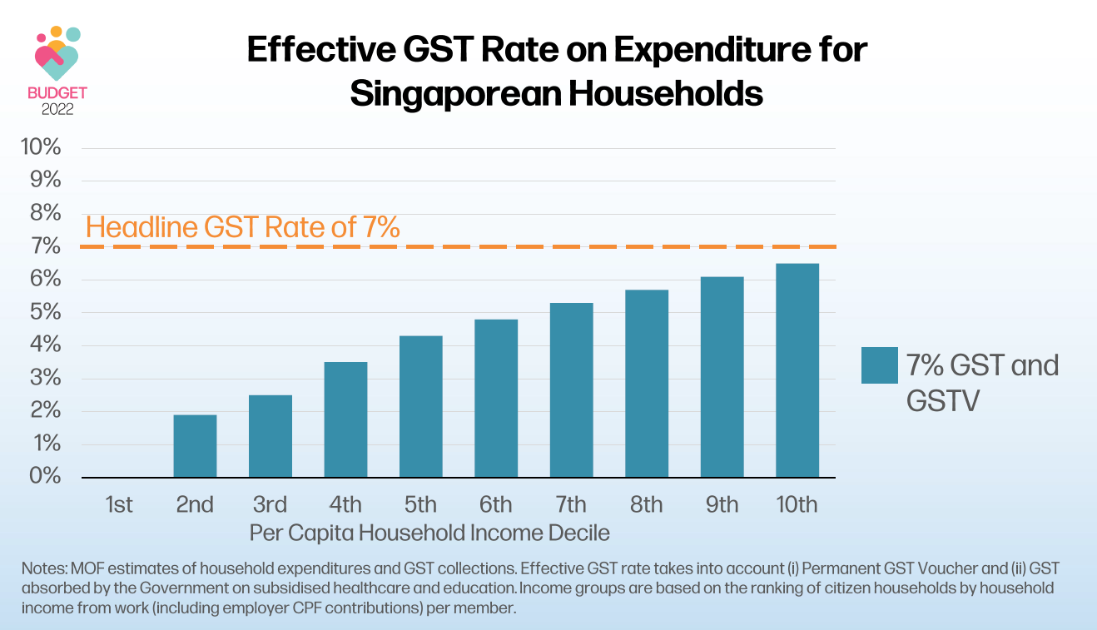

- Essentially, we already have a highly-tiered GST system in Singapore – but it is not tiered by the different types of goods or services which Ms He had asked for. Instead, it is tiered by the impact of our GST, such that the well-to-do pay more GST, and the lower-income are impacted the least. That is a fairer and far more effective way of taxing consumption.

- Many Members of the Opposition, both the WP and the PSP, object to the very idea of raising GST – claiming that the payouts are temporary, and that the GST is regressive and disproportionately impacts the poor. But again such misguided claims ignore the way we have implemented GST in Singapore.

- [Chart] What happens when the GST rate is raised to 9%? Together with the enhanced permanent GST Voucher scheme, you can see from this chart, the effective GST rate for the first three deciles remains unchanged. For them, the enhanced permanent GST Voucher neutralises the impact of the increase in GST. So, it is not true that the GST increase hurts the poor. Not in the way we have designed it. Even the middle-income continues to pay an effective rate which is well below the headline 9% rate.
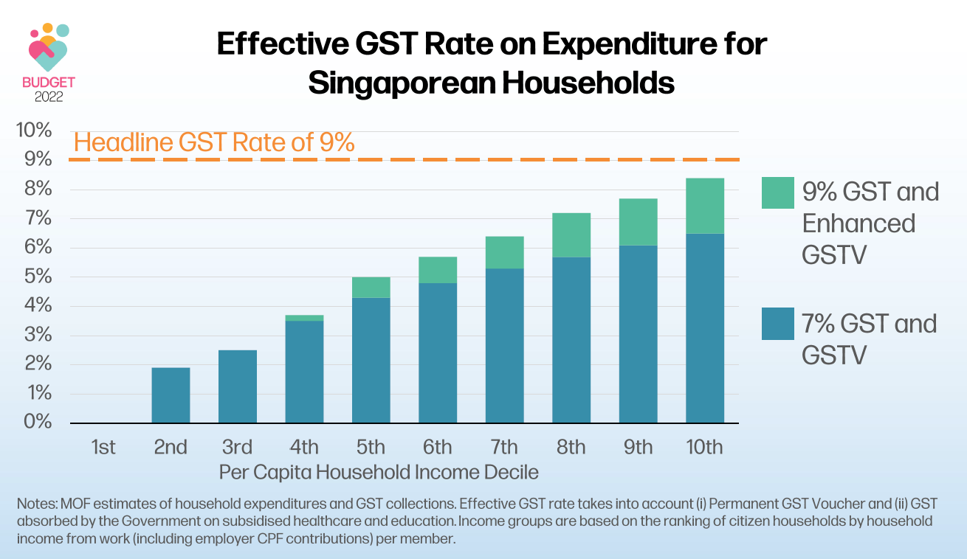

- There is another effect of the GST which causes it to bear more heavily on the well-off. A consumption tax also allows us to tax those who may not be earning income in Singapore, but are in fact well off. They may be investors or persons of means. They may not be paying much in income tax today, even though they have the means to contribute, because their income is not easily ascertained, and that could be for example, if they are self-employed. But they will certainly be consuming more, and the GST ensures that such people, those with greater means will contribute their fair share of taxes.

- Now Mr Leong Mun Wai had made some calculations and he concluded that the middle income will bear a disproportionate burden of the GST increase. But that is not so. After the GST rate increase, it is the top 20% of citizen households who pay a greater share of GST, and that is after GST Voucher and the absorbed GST that is netted off. For the top 20%, the share goes up from 40% to 42%. The middle 20% of households, they will pay a slightly smaller share of GST.
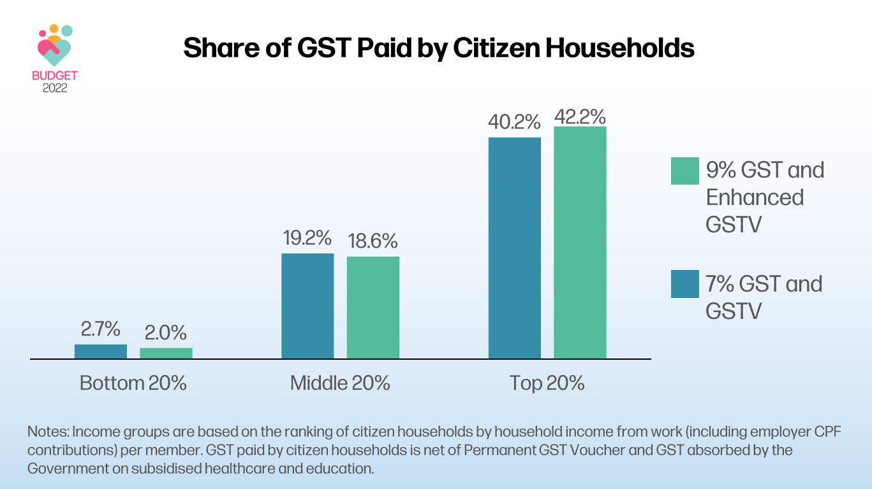

Overall Tax System
- Sir, I have covered the issues around GST and the various revenue options. I would like to assure members that we have studied and carefully considered every tax option. I appreciate that the Workers’ Party offered suggestions on alternatives to the GST. In fact, we have studied every tax option, even before the Budget, in order to design what we have put together as part of a package of tax changes in this Budget. We have looked at all the options again. As I have explained there are limitations to all these different proposals. In some cases, the sums just do not add up. Every tax move we make is carefully considered. This is so that we have, in the end, a balanced, effective and fair set of tax measures in the Budget.

- More importantly, a progressive fiscal system does not and should not mean that each and every tax is progressive, let alone highly progressive. What ultimately matters is the overall system of taxes and transfers is progressive. This is what we have done. If we take a revenue by revenue approach, you will end up with less revenue, and you will also undermine the broader need for everyone to contribute as part of a durable social compact.

- In this regard, I should say there is a fundamental difference between the measures we have put forward in the Budget and the Workers’ Party alternative proposals, or the position taken by the PSP. From what I have heard in this Debate, the basic position of the WP and PSP is that we can close the funding gap without having to raise the GST. How? By making various groups pay more. Make the wealthy pay more. Make large companies pay more. Let future generations pay more. Anything but the GST increase, even though I have already explained the GST increase in Singapore does not hurt the poor. I can understand why these alternatives are politically more attractive options to offer. But they are too simplistic and divisive, and will end up creating more problems for our society.

- Let me explain. The bottom line is that we cannot sustain a tax system where the bulk or all of the burden is borne by a small group of people at the top end. It will not be possible to hold our society together if only a small group of people are required to pay more taxes all the time, while the rest simply get to piggy-back on their contributions to enjoy more benefits.

- That is why having a broad-based tax like the GST is so vital. It makes a direct link between our demands as voters and our responsibilities as citizens. Break that link and we encourage irresponsible lobbying and playing to the gallery. Someone else will pay for the good things in life. Why not demand more?

- That is how we have designed our system – on the principle of collective responsibility. Everyone contributes towards the cost of delivering services, and everyone benefits from these services, but to different degrees. Those with greater means bear a higher burden, and they draw less on Government support, but they still enjoy some benefits from the Government. Those with fewer means carry a lighter share, but they still contribute something, and in return they receive more benefits from the Government – more than they put in, and more than the better off. In this way we all do our part to help ourselves and one another, and we strengthen the trust that binds us together as a society. This is a fair and inclusive system.

- We should also remember that the well-to-do contribute in many other ways, and not just through income or wealth taxes. For example, many have set up businesses in Singapore, creating good jobs for Singaporeans and helping to develop new capabilities in our economy. While these individuals are here in Singapore, they consume more and pay more in GST. Some also set up philanthropic foundations, contributing to our charities and other worthy causes. Ms Foo Mee Har and Ms Denise Phua spoke about enhancing our framework around philanthropy and we will certainly do so.

- I want to make it very clear too that we have no issue with people doing well, earning more and achieving success in their careers. Our tax system must never discourage hard work, effort and enterprise. At the same time, we want to avoid in Singapore the emergence of stark income inequalities or social stratifications, which will undermine social cohesion and pull us apart.

- So we will continually review and update our system of taxes and transfers to achieve this balance – to reward enterprise, innovation and work, and to mitigate the pressures of social inequalities. We will continue to ensure a fairer and more resilient fiscal structure to underpin our social compact, and to strengthen our social solidarity. Many Members in this House, Mr Liang Eng Hwa, Ms Rachel Ong and Mr Xie Yao Quan, have affirmed this, and I thank everyone for your strong support.

A Fair and Progressive Budget
- Finally, let me address the third major question – is the Budget fair to all Singaporeans.

- The Budget has something for everyone. It is designed to provide opportunities for all to succeed: the young and the old; the lower-income, the middle-income, and even the higher-income.

- In fact, a significant part of our social spending goes towards ensuring broad access to affordable and quality housing, healthcare, education and lifelong learning. These are important social provisions and they support the aspirations of all Singaporeans. But we have also been careful to design our schemes so that those who come from less well-off backgrounds will get more support.

- I assure members like Dr Shahira and Mr Abdul Samad that we will continue to review our eligibility criteria and schemes, so that the support is sufficient and targeted towards those in need.

- We are continuing with this emphasis in this Budget to provide for all, but to tilt the support towards those who need them more. Over the last decade, our policy moves have helped to reduce income inequalities, and steadily brought down the Gini coefficient. As Mr Mohd Fahmi and Mr Raj Joshua said, we are determined to continue reducing wage disparities, despite the global economic pressures that are pulling incomes apart and making it harder to hold our society together. That is why we are setting aside significant resources in this Budget for both Progressive Wage and Workfare. This reflects our shared commitment for a fairer and more equal Singapore. I assure everyone that we are moving as fast as we can to uplift wages of these lower wage workers. The new Local Qualifying Salary (LQS) requirement will take effect soon, from 1 September this year. We will work with our tripartite partners to get employers to come on board quickly even before the mandatory progressive wage requirements kick in.

- Overall, our system of taxes and benefits continues to be fair and highly progressive [Chart].

  - I will show a chart to reflect this. This chart depicts the overall net benefits, including grants and subsidies, that Singaporeans receive in a year from the Government, after subtracting the taxes they pay.

  - As you can see here, our seniors are well taken care of. Retirees, on average receive $6,900 in net benefits per member.

  - Among Singaporean employed households, the benefits net of taxes are significant, at $5,900 per member for the bottom decile. When you add that up for a typical household, the benefits work out to about 90% of their household income. Put another way, government benefits will nearly double the amount of resources for these households. It is a significant and tangible form of support.

  - Of course, as incomes go up, the net benefits are correspondingly reduced. The higher-income are net contributors – they contribute more than they receive. But they too benefit, they benefit from the political stability, social cohesion and the overall environment that we provide in Singapore.

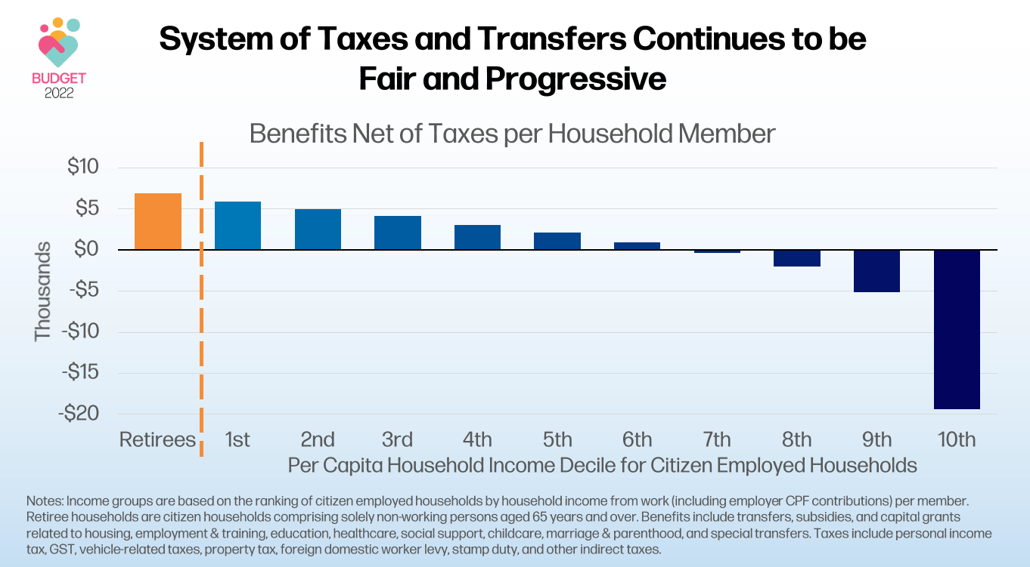

- Some Members have asked if we are doing enough for the sandwiched middle-income group.

  - If you look at the chart, for those in the 40th to 60th percentiles of household income, they continue to receive more benefits than the taxes they pay.

  - For those in the 60th to 90th percentiles of household incomes, they pay some taxes after netting of the subsidies and transfers they receive.

  - I understand the pressures faced by this group. Some are caregivers who bear a heavy burden financially and emotionally, even physically. This is why we have been mindful to make sure we expand our suite of broad-based support, in areas like education and healthcare. We have also increased healthcare and caregiving-related subsidies and support, to relieve the load on these families, especially for those who care for young ones and elderly parents.

  - Importantly, we have taken extra care to keep the tax burden for this group low. In fact, their tax burden is significantly lower than what it is for their equivalent in most other cities. For the relatively low amount of taxes they pay, they enjoy many benefits in Singapore – affordable public housing and healthcare, beautiful parks, excellent infrastructure, quality pre-schools, schools and tertiary institutions with highly subsidised fees.

- When you put it all together, this is how we designed our fiscal system.

  - One, a fair revenue structure, with everyone contributing, but those who have greater means contribute more.

  - A fair system of subsidies and transfers, where all benefit, but those who are less well-off benefit more.

  - A system where we keep taxes on middle income households low, by targeting our social safety nets at the more vulnerable households who really need the support, while ensuring universal access to high quality public housing, education, and health care.

  - When you put all three together, we have a progressive system of taxes and transfers – where the better-off contribute more and receive less in tax-funded benefits, while the less well-off still contribute, but a smaller amount, and receive much more in benefits.

- This is reflected in our benefit-to-tax ratios [Chart]. Something that many Members are familiar with, but it is worth reiterating.

  - The bottom 20% of Singaporean households receive about $4 in benefits for every tax dollar paid.

  - The middle 20% of Singaporean households receive about $2 in benefits for every tax dollar paid.

  - The top 20% of Singaporean households are net contributors of tax – receiving about $0.30 in benefits for every tax dollar paid.

  - These ratios we have achieved for the lower- and middle-income households are no mean feat. We will have to continue to work hard to maintain this in the coming years.

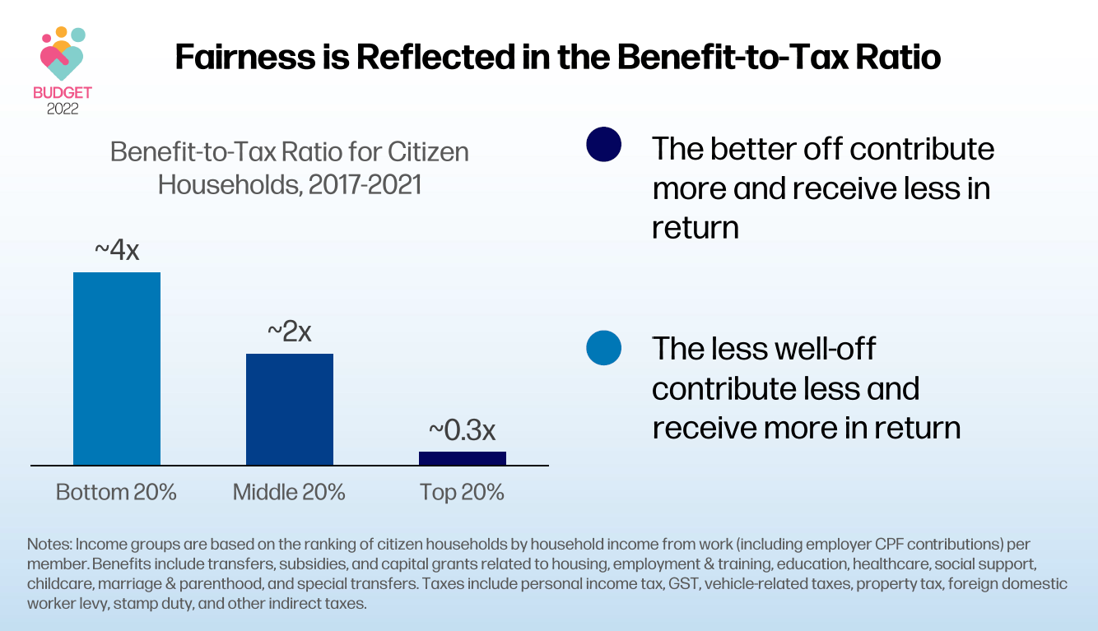

- I started work more than 25 years ago as an economist in MOF. In that sense, I have been through many Budgets, even though this is my first time delivering one. Over the years, I have had the chance to study the fiscal systems of many other jurisdictions. I can confidently say that Singapore is unique in having such a highly progressive system of taxes and transfers, while keeping the overall tax burden low for everyone, and especially for the middle-income. We have a system that is progressive, fair and effective. It reflects our values – what we stand for, and who we are as a people, and it provides a strong foundation for us to build our economy and our society.

- That does not mean we have a perfect system. We are continually reviewing and improving it. We are continually adapting and adjusting our approach, as circumstances change and as our society evolves. Typically, after a Budget, we get two types of responses: “too much” and “too little”.

  - On the one hand, some say that the Government is doing too much; making costs higher for SMEs and consumers. On the other hand, there are voices that say we are doing too little. Not enough taxes for certain groups. More is better.

  - After 25 years of public service, I know it is almost impossible for the Government to do anything that pleases everyone all of the time.

  - But I want to assure everyone that every move we make is considered very carefully – we weigh the costs and benefits, and the implications; we discuss extensively with all our stakeholders, especially our tripartite partners.

  - That is what the team and I in MOF have worked very hard to do in this Budget – to ensure a balanced and fair package of measures, adjusting what is necessary to meet our evolving needs, while bearing in mind our economic and social imperatives, and above all, upholding the principles of fiscal prudence and sustainability.

  - That is the approach we will continue to take in reviewing and updating our policies – never compromising on our principles and values, and always doing what is in the best interests of Singapore and Singaporeans.

- Mr Speaker Sir, let me say a few words in Mandarin.

- 今年的财政预算案，惠及所有国人，并将为大家提供机会，帮助人民迈向成功。

- 我能理解国人对物价与生活费上涨的担忧。政府会尽全力帮助人民减轻负担。

- 因此，我决定把消费税的上调推迟到2023年，并分两步调高到百分之9。

- 今年，我们也推出了家庭援助配套，这将大大协助减轻国人的负担。符合条件的组屋家庭今年会得到双倍的消费税补助券水电费回扣。他们孩子的教育也能获得补贴。而每户新加坡家庭今年也获得社理会邻里购物券，以应付日常开销。

- 我明白不少人担心乌克兰危机所带来的影响。政府正在密切关注局势的发展。如果局势恶化，我保证，政府将为国人与企业提供更多援助，以应付生活费与营业成本上涨的问题。

- 也有人担心，即使延迟并分阶段提高消费税，物价还是会上涨。

- 所以，我们将推行加强版的定心与援助配套与加强版的永久性消费税补助券计划，帮助国人抵消他们的消费税支出。我们会在消费税调高之前，先让国人在今年就获得补助，希望这有助于大家定一定心。

- 在这两个计划下，国人所得到援助，相当可观。

- 例如，一家四名成员，住在三房式组屋，月薪2千500元的家庭，在接下来的五年，每年平均可获得大约2千400元的补助。这将足以抵消他们5年的消费税支出。

- 我们也会照顾中等收入家庭和“夹心层”群体。他们也将从这两个计划中受惠，得到的补助也不少。

- 新加坡的消费税制度整体来说是独一无二的。
  - 低收入家庭缴纳的消费税，比高收入家庭少。

  - 除了消费税，我们在这次的财政预算案也优化了税收结构，例如调高对高收入群体的个人所得税，也上调了住屋年值三万元以上房地产税。

- 这些调整将让我们增加税收，以资助发展项目和应付更庞大的政府开支。这些收入将用来支付日益增加的医疗保健开支，让我们能更好地照顾我们的年长者。

- 我们会以一个公平和累进的方式进行。

  - 这意味着，每个人都应该做出贡献。

  - 收入较低的群体所缴的税，数额比较少，但获得的援助更多。

  - 而收入较高的群体所缴的税，则比他们所得到的援助多。

- 有议员建议动用更多的储备金来应付所有额外开支需求。但这不是长远之计，因为不断动用我们的储备金来填补资金短缺的问题，只是在“寅吃卯粮”。这么做，总有一天会花光我们的储备金。

- 我们必须负起责任守住辛苦累积的储备金，不随意挥霍。我们必须谨慎理财，未雨绸缪。这样，我们才能让新加坡的财富一代一代传下去，造福我们的子孙后代。

- 今年的预算案在税务结构上做了一些调整，我相信这会加强我们的社会契约与凝聚力。因为大家都会有所贡献，互相扶持，携手开拓前进路，让新加坡的未来更加美好。

- 这样，我们才能一起创造一个更公平，更包容的社会，没有人会被抛在后头,大家都能享有国家繁荣发展的果实。

Conclusion
- Mr Speaker Sir, in every Budget, we discuss and debate the design of policy parameters or schemes in monetary terms. But the Budget is much more than that. It reflects something deeper – our ethos and our values. It is an expression of our shared compact to tackle our challenges today together, to never stop thinking of tomorrow, and to never cease building a better Singapore.

- All this boils down to trust, something the Prime Minister spoke about recently in this House – trust between the Government and the people; the trust we have in one another; and trust across the generations.

  - Trust is fragile and precious – it takes effort and time to build up, but it can be destroyed very quickly.

  - When there is trust, we can achieve great things together. We can make the impossible possible. But when we lose faith in one another, even simple things become impossible.

  - Whatever views we may have about the Budget, whatever differences we may have on policy issues, let us always work to strengthen trust in our institutions and in one another.

  - That means debating the issues based on facts, not biased soundbites, or worse half-truths and lies. It means being honest and upfront with Singaporeans about what we need to do together; not sugar-coating realities or pretending that there are quick and painless remedies available.

- In this Budget, I have set out plainly the challenges and also the opportunities ahead of us, and explained why we need to move on difficult measures like the GST increase. It is not a popular thing for me to do, certainly not for my first Budget speech as Finance Minister. But I have a responsibility to do what is right and in the best interests of all Singaporeans; not what is politically expedient now, but will store up problems for the future.

- I am convinced that the measures in the Budget are necessary and will put us in a stronger position – to strengthen the self-reinforcing system of trust we have now, and to ensure that every citizen contributes their fair share to building our common enterprise, which is Singapore.

- A lot has been said about the redistributive aspects of the Budget. But in fact, to deepen the trust we have in one another, we must also engage the human spirit and involve every Singaporean. We must strengthen the culture of responsibility for one another, so we all feel a renewed sense of duty towards each other, and not just a right to the benefits of citizenship.

- Singapore must always remain an open and egalitarian society – one without rigid hierarchies and class distinctions, but with a big heart and a generosity of spirit. We do not begrudge those who do well. Instead, we celebrate them and we take pride in their achievements. At the same time, for those who have succeeded, there is no need to flaunt one’s wealth or be ostentatious about it. Instead, keep a modest and unassuming approach, and do your part to give back to society, so that wealth can be recycled and invested back into society to expand opportunity for others.

- Mr Speaker Sir, I have confidence that Singaporeans can instinctively sense if any Budget is not worthy of them and fails to renew their trust in the Government, in each other, and in the future. They can decipher whether the Budget reflects our shared vision of a fair and just society, whether this Government is one they can trust to manage our resources in a way that is in line with our values, and whether this Government is keeping faith with them and their children.

- In the weekend immediately after the Budget, I had several engagement sessions.

  - Someone shared with me that his wife asked him: “Why are you so happy to pay more taxes?” This is by no means a well-to-do individual, this is an ordinary person. His reply is “It is the right thing to do.”

  - In a dialogue organised by the CDCs including their community and corporate partners, a participant said she did not need the cash payout from the Assurance Package, and would like to donate it to families with greater needs.

  - I was cheered by this, and I am glad to share that we will have an online portal set up in the coming months, where Singaporeans can indicate their preferred charities for the Government to directly channel the payout to, if they wish.

- In the end, the Budget is about all of us as Singaporeans – driven by our compassion and our conviction to build a better society for all; strengthening our trust in each other; and keeping faith with future generations, as our forefathers kept faith with us. And Sir, as one united people, we can be confident in charting our new way forward together, and in building a fairer, greener and more inclusive Singapore together.

- Thank you, Sir.

